**Deployment documentation**

**DCS Project**

October 2020

*David Vicente Fuentes*

1. **Software used in the deployment**

In this chapter, you will find all software involved in the deployment process

* **Operating System:** As Node.js is a cross-platform server, nonspecific operating system is required, but Linux is recommended.
* **Git:** As the code of the project is allocated in github, git is needed for cloning the project and updates if needed.
* **Node.js:** The server used for the project is Node.js, so Node.js + npm are needed to be installed
* **Pm2:** We will use pm2 for process managing, for starting and monitoring purposes.

1. **Deployment architecture**

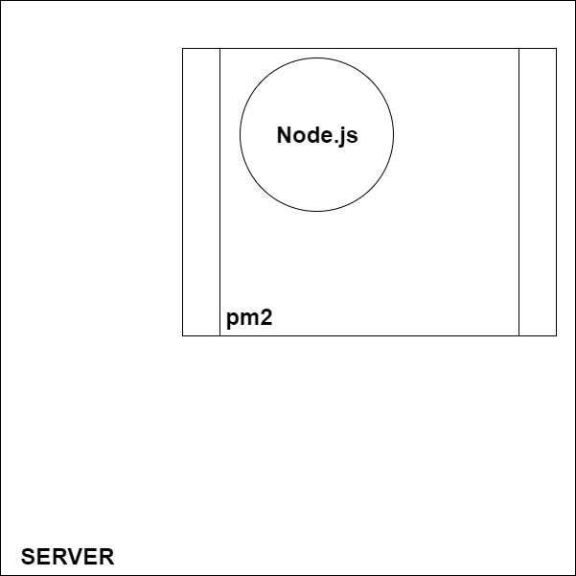

The architecture of the project is as shown in the picture. The backend is hosted in a server, which can have any operating system (as Node.js is cross-platform).

Pm2 will be used for running the server, monitoring and keeping it alive.

Finally we have the backend project running over Node.js.

1. **Deployment process**

These are the steps to get the server running (we are going to suppose it is a linux machine, but in other operating systems commands should be pretty similar):

* Once we are in the server machine, with all software needed installed, first thing we have to do is clone the project.

*cd /opt*

*mkdir dcs_server*

*cd /dcs_server*

*git clone* [*https://github.com/davicente/dcs_server.git*](https://github.com/davicente/dcs_server.git)

* Once it is cloned, install all dependencies

*cd dcs_server*

*npm install*

* Apply any changes in configuration if needed. For this, open .env file and change any values required (e.g.: port number).
* Run the server with pm2 so it can be monitored with other node applications running in same machine.

*pm2 start npm –name “dcs_server” – start*